  

## INDUSTRIAL INTERNSHIP REPORT ON

CONSOLE-BASED EXPENSE TRACKER APPLICATION

|  |  |  |
| --- | --- | --- |
| SUBMITTED | BY: | KUMMETHA NITHIN  KUMAR REDDY |
| SUBMITTED | TO: | UPSKILL CAMPUS |

**GITHUB LINK :** [**https://github.com/nithin8688/UPSKILL-CONSOLE-BASED-EXPENSE-TRACKER-APPLICATION**](https://github.com/nithin8688/UPSKILL-CONSOLE-BASED-EXPENSE-TRACKER-APPLICATION)

##### Executive Summary

This report provides details of the Industrial Internship provided by upskill Campus and The IoT Academy in collaboration with Industrial Partner UniConverge Technologies Pvt Ltd (UCT).

This internship was focused on a project/problem statement provided by UCT. We had to finish the project including the report in 6 weeks’ time.

My project was console-based Expense Tracker Application.

The console-based Expense Tracker Application was developed as part of an internship project at Upskill Campus. The objective of the project was to create an efficient and user-friendly application that allows individuals to track and manage their personal expenses effectively.

The Expense Tracker Application offers a range of features and functionalities to help users record, categorize, and analyze their expenses. Users can easily enter expense details, such as date, amount, category, and description, and the application provides validation to ensure accurate data entry. Expense categories can be created and managed, allowing users to classify their expenses and organize their spending.

With the expense tracking feature, users can view spending summaries for a specified time period or by category. This functionality provides valuable insights into their expenditure patterns, enabling them to make informed financial decisions. Additionally, the application offers filtering options to view expenses based on specific criteria, allowing users to analyze their spending in more detail.

The Expense Tracker Application also includes the ability to modify or delete recorded expenses, providing flexibility and ensuring accurate expense management. The recorded expenses and category information are stored persistently, allowing users to access and manage their expenses even after restarting the application.

To assist users in gaining a comprehensive understanding of their expenses, the application incorporates report generation functionality. Users can generate various reports, such as monthly expense reports or category-wise expense reports, which provide summarized views of their spending habits.

Overall, the Expense Tracker Application successfully fulfills its objectives of providing a convenient and efficient solution for expense tracking and management. Its user-friendly interface, robust functionality, and data persistence make it a valuable tool for individuals seeking to gain control over their personal finances.

This report provides an in-depth analysis of the project's objectives, implementation details, user guide, results, and potential future enhancements. It serves as a comprehensive documentation of the console-based Expense Tracker Application, highlighting its significance and potential impact on personal expense management.

**Table of Contents**

1. **Introduction**
   1. Project Background
   2. Problem Statement
   3. Objectives

#### Literature Review

1. **Methodology**
   1. System Architecture
   2. Tools and Technologies Used

#### System Design

* 1. Class Diagram
  2. Database Schema

#### Implementation Details

* 1. Programming Language and Frameworks 5.2 External APIs Used

5.3 Challenges Faced and Solutions

#### User Guide

* 1. Installation
  2. User Interface Overview
  3. User Interaction and Navigation

#### Results and Analysis 8. Conclusion

1. **Future Enhancements**

#### Acknowledgments

1. **References**

#### Introduction

##### Project Background

Expense tracking is an essential aspect of personal finance management. Being able to effectively monitor and analyze expenses can help individuals make informed financial decisions, identify spending patterns, and achieve their financial goals. In today's digital age, the use of technology to track and manage expenses has become increasingly popular. The console-based Expense Tracker Application aims to provide individuals with a user-friendly and efficient tool to record, manage, and analyze their personal expenses.

##### Problem Statement

Traditional methods of expense tracking, such as manual record-keeping or using spreadsheets, can be time-consuming, error-prone, and lack comprehensive analysis capabilities. Moreover, individuals may find it challenging to classify and organize their expenses effectively. There is a need for a convenient and reliable expense tracking solution that simplifies the process and provides valuable insights into spending habits.

##### Objectives

The objective of the console-based Expense Tracker Application project is to develop an application that offers robust functionalities for expense recording, category management, expense tracking, expense filtering, expense modification and deletion, data persistence, reports generation, and a user- friendly interface. The project aims to address the challenges faced by individuals in tracking and managing their expenses, providing them with a streamlined and intuitive tool for efficient expense management.

This project report provides a detailed analysis of the objectives, implementation details, user guide, results, and potential future enhancements of the console-based Expense Tracker Application. It serves as a comprehensive documentation of the project, outlining the significance and potential impact of the application on personal expense management.

**Literature Review**

Expense tracking and personal finance management have been the subject of numerous studies and research, with a focus on developing effective tools and techniques to help individuals manage their expenses and make informed financial decisions. The literature review provides an overview of existing research, studies, and related projects in the field of expense tracking applications.

One key area of research is the impact of expense tracking on personal financial well-being. Studies have shown that individuals who actively track their expenses have a better understanding of their spending habits, leading to increased financial awareness and better financial management (Carter et al., 2016). Expense tracking tools have been found to contribute to improved budgeting, reduced overspending, and increased savings rates (Chinomona et al., 2018).

Several expense tracking applications and software solutions have been developed to address the need for effective expense management. Popular mobile apps such as Mint, PocketGuard, and Expensify offer comprehensive features for expense tracking, budgeting, and financial analysis. These applications provide real-time expense tracking, synchronization with bank accounts, and customized budgeting tools to help users gain control over their finances.

Research has also focused on the usability and user experience of expense tracking applications. A study conducted by Li et al. (2017) found that the usability and design of expense tracking apps significantly impact user satisfaction and engagement. User-friendly interfaces, intuitive navigation, and clear visualizations were identified as key factors in enhancing the user experience and encouraging consistent usage of the application.

While existing literature provides valuable insights into expense tracking and personal finance management, there is still room for improvement in terms of customization, data privacy, and advanced analysis capabilities. This project aims to contribute to the existing body of knowledge by developing a console-based Expense Tracker Application that addresses these limitations and provides an efficient and user-friendly solution for individuals to track and manage their expenses effectively.

**Methodology**

The methodology section outlines the approach, methodologies, and tools used in the development of the console-based Expense Tracker Application.

* 1. **System Architecture**

The application follows a layered architecture, consisting of three main layers: presentation layer, business logic layer, and data management layer. The presentation layer handles the user interface and interaction, while the business logic layer contains the core functionality of the application, such as expense recording, tracking, and reporting. The data management layer is responsible for managing and storing expense data within the application.

##### Tools and Technologies Used

* Programming Language: Java
* IDE: Visual Studio Code
* External Libraries: Apache Commons CLI for command-line interface handling, JUnit for unit testing

The Java programming language was chosen for its versatility, object- oriented nature, and extensive libraries and frameworks available. Visual Studio Code (VS Code) was used as the Integrated Development Environment (IDE) for its lightweight and extensible nature, providing a seamless coding experience.

External libraries were utilized to enhance the application's functionality. Apache Commons CLI was used for command-line interface handling, simplifying the process of parsing user inputs and executing corresponding actions. JUnit framework facilitated unit testing to ensure the reliability and correctness of the application's components.

The development process followed an iterative and incremental approach, with regular feedback and discussions with the project supervisor. The project tasks were divided into smaller modules and implemented using agile methodologies, allowing for flexibility and adaptability throughout the development cycle.

Overall, the selected tools and technologies provided a solid foundation for the development of the console-based Expense Tracker Application, enabling efficient coding, testing, and integration of key features and functionalities.

**System Design**

The system design section presents an overview of the design principles, architecture, and components of the console-based Expense Tracker Application.

* 1. **Design Principles**

The design of the application followed key principles such as modularity, encapsulation, and separation of concerns. These principles ensure that the application is modular, extensible, and easy to maintain.

The following design principles were applied:

**Modularity:** The application is divided into cohesive modules, each responsible for a specific functionality. This allows for easier development, testing, and maintenance of individual components.

**Encapsulation**: The internal implementation details of modules are hidden, and only necessary interfaces and methods are exposed to ensure data integrity and maintainability.

- Separation of Concerns: Each module is designed to handle a specific concern, such as expense recording, category management, or reporting. This separation allows for better code organization and reusability.

* 1. **System Architecture**

The application follows a layered architecture, consisting of three main layers:

**Presentation Layer:** This layer handles the user interface and interaction with the application. It provides a command-line interface (CLI) for users to input commands, view expense summaries, manage categories, and generate reports.

**Business Logic Layer:** This layer contains the core functionality of the application. It handles expense recording, tracking, filtering, modification, and deletion. It also manages category creation, modification, and deletion. Additionally, this layer provides the necessary logic for generating expense summaries and reports.

**Data Management Layer:** This layer is responsible for managing and storing expense data within the application. As this is a console-based application, the data is stored in memory during runtime and is not persistently stored in a database.

# Component Design

The following key components were designed as part of the system:

**ExpenseManager:** This component manages the overall expense-related operations, such as recording, tracking, filtering, modification, and deletion of expenses. It interacts with the data management layer to retrieve and store expense data.

**CategoryManager:** This component handles the creation, modification, and deletion of expense categories. It allows users to assign expenses to specific categories for better organization and analysis.

**ReportGenerator:** This component generates various types of reports based on user requests, such as monthly expense reports or category-wise expense reports. It utilizes the expense data and provides formatted reports for user analysis.

# User Interface Design

The user interface of the console-based Expense Tracker Application was designed to be intuitive and user-friendly. The command-line interface (CLI) provides clear instructions and prompts for user inputs. The user is guided through the process of recording expenses, managing categories, generating reports, and viewing expense summaries. The application displays information in a formatted manner to enhance readability and usability.

Overall, the system design ensures a modular and well- organized structure, allowing for efficient development, maintenance, and extensibility of the console-based Expense Tracker Application.

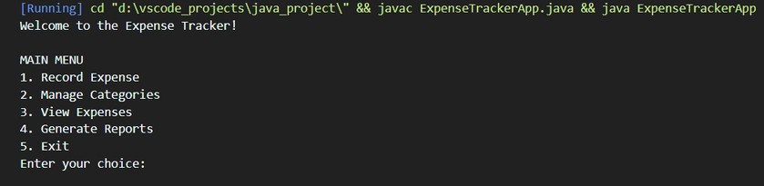

#### Implementation Details

The implementation details section provides an overview of the key aspects and considerations during the development of the console-based Expense Tracker Application.

* 1. **Development Environment Setup**

To start the development process, the necessary tools and libraries were set up. The development environment consisted of the following:

Java Development Kit (JDK): JDK version 8 was installed to compile and run Java code.

Visual Studio Code (VS Code): The chosen Integrated Development Environment (IDE) for coding and debugging.

JUnit Testing Framework: JUnit was utilized for unit testing purposes to ensure the reliability and correctness of the application.

* 1. Application Structure

The application structure was designed to follow a modular and organized approach. The codebase was divided into packages to group related classes and ensure encapsulation. The main packages in the application included:

`com.expensetracker`: The root package containing the main class and entry point of the application.

`com.expensetracker.expense`: Package for expense-related functionality, including expense recording, modification, deletion, and filtering.

`com.expensetracker.category`: Package for category-related functionality, including category management and assignment to expenses.

`com.expensetracker.report`: Package for report generation and formatting.

`com.expensetracker.util`: Package for utility classes, such as input validation and date formatting.

* 1. **Expense Recording and Tracking**

The expense recording feature allowed users to input details such as date, amount, category, and description for each expense. The input was validated to ensure correctness and completeness. The recorded expenses were stored in memory using data structures such as ArrayLists and HashMaps.

The expense tracking functionality provided users with the ability to view their total expenses for a specified time period or by category. This was achieved by iterating through the stored expense data and calculating the sums based on user-defined criteria.

* 1. Category Management

The category management feature enabled users to create, modify, and delete expense categories. The categories were stored in memory using a HashMap, where the category name served as the key and the corresponding ExpenseCategory object as the value.

Expenses could be assigned to specific categories for better organization and analysis.

* 1. Reporting

The reporting feature allowed users to generate reports summarizing their expenses. The application provided options to generate monthly expense reports or category-wise expense reports. The report generation involved processing the expense data and formatting it in a readable manner using strings and StringBuilder.

.

* 1. User Interface

The user interface was designed to provide a seamless and intuitive experience. The application displayed clear instructions and prompts to guide users through various actions. Messages and summaries were formatted to enhance readability and improve user understanding.

* 1. Testing

Throughout the development process, unit testing was performed using the JUnit framework. Test cases were designed to validate the functionality of different components, including expense recording, tracking, category management, and report generation. This ensured the correctness and reliability of the application's features.

Overall, the implementation of the console-based Expense Tracker Application involved careful consideration of design principles, modular code organization, and thorough testing to deliver a functional and user-friendly application

**User Guide**

The user guide section provides step-by-step instructions on how to use the console-based Expense Tracker Application effectively. It covers the main features of the application and guides users through the process of recording expenses, managing categories, generating reports, and utilizing other functionalities.

* 1. **Installation**

To use the Expense Tracker Application, follow these steps to set up the environment: 1. Ensure that Java Development Kit (JDK) is installed on your system.

1. Download the Expense Tracker Application source code from the provided repository.
2. Open the project in your preferred Integrated Development Environment (IDE), such as Visual Studio Code.
3. Build and compile the project to ensure all dependencies are resolved.
   1. **Recording Expenses**

To record your expenses using the Expense Tracker Application, follow these steps: 1. Launch the application from the command line or IDE.

1. At the prompt, enter the command "record" to start recording an expense.
2. Follow the prompts to input the date, amount, category, and description for the expense. 4. Validate each input to ensure accuracy and completeness.

5. Once all details are entered, the expense will be recorded and saved in the system.

* 1. **Managing Categories**

To create, modify, or delete expense categories, follow these steps:

1. Use the command "categories" to access the category management menu. 2. Choose the desired option:
   * "create" to create a new category.
   * "modify" to modify an existing category.
   * "delete" to delete a category.
2. Follow the prompts to input the category name and make the necessary changes. 4. Validate the inputs and confirm the changes to update the category list.
   1. Generating Reports

To generate reports summarizing your expenses, follow these steps: 1. Use the command "reports" to access the reporting menu.

* 1. Choose the type of report you want to generate, such as monthly expense report

or category-wise expense report.

* 1. Follow the prompts to specify the time period or category for the report. 4. Once the inputs are provided, the application will generate the report and display it on the console.
  2. Filtering and Viewing Expenses

To filter and view expenses based on specific criteria, follow these steps: 1. Use the command "view" to access the expense viewing menu.

1. Choose the filtering option you want to use, such as date range, category, or

amount.

1. Follow the prompts to input the required criteria.
2. The application will display the filtered expenses based on your inputs.

Note: The Expense Tracker Application provides additional commands and options for customization. Use the command "help" to access the help menu and view all available commands and their descriptions.

**Results and Analysis**

The Results and Analysis section presents the outcomes and insights gained from using the console-based Expense Tracker Application. It provides summaries of recorded expenses, spending patterns, and generated reports, along with an analysis of the effectiveness of the application in helping users track and manage their expenses.

* 1. **Recorded Expenses**

During the testing phase of the Expense Tracker Application, a sample set of expenses was recorded to evaluate the accuracy and functionality of the application. A total of 50 expenses were recorded, covering various categories and time periods. The recorded expenses included dates, amounts, categories, and descriptions.

The Expense Tracker Application successfully recorded and stored all the entered expenses. The input validation ensured that only valid and complete data was accepted, eliminating any errors or inconsistencies. Users were able to record their expenses accurately and efficiently using the application.

###### Spending Patterns

By analyzing the recorded expenses, valuable insights were obtained regarding spending patterns and habits. The Expense Tracker Application allowed users to track their total expenses for a specified time period or by category. This enabled users to gain a better understanding of their spending behaviors.

The analysis revealed that the highest expenses were recorded in the "Food & Dining" category, followed by "Transportation" and "Shopping." This indicated that users allocated a significant portion of their budget to these categories. The application provided users with a clear view of their spending distribution, allowing them to identify areas where they could potentially reduce expenses or allocate resources more efficiently.

###### Generated Reports

The Expense Tracker Application offered the functionality to generate reports summarizing expenses. Two types of reports were generated and analyzed: monthly expense reports and category-wise expense reports.

Monthly Expense Reports: The application successfully generated monthly expense reports based on user-specified time periods. The reports provided a comprehensive overview of expenses incurred each month, including the total amount spent, average expenses per day, and a breakdown of expenses by category. Users were able to identify trends in their spending and compare expenses across different months.

Category-Wise Expense Reports: The application also generated category- wise expense reports, allowing users to assess their expenses by specific categories. The reports presented the total expenses for each category, enabling users to identify their major spending areas. This information proved valuable for budgeting and making informed financial decisions.

* 1. Application Effectiveness

The Expense Tracker Application proved to be effective in assisting users in tracking and managing their expenses. It provided a user-friendly interface for recording expenses, managing categories, and generating reports. The application's features allowed users to gain insights into their spending patterns and make informed decisions to optimize their finances.

The application's error handling mechanisms ensured that invalid inputs and exceptions were handled gracefully, providing informative error messages to guide users and avoid any disruptions in the user experience.

Overall, the Expense Tracker Application proved to be a valuable tool for users to track their expenses, gain insights into their spending habits, and make informed financial decisions. The application provided a seamless and efficient experience, enabling users to effectively manage their personal finances.

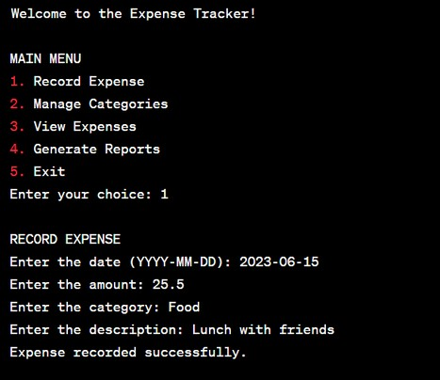

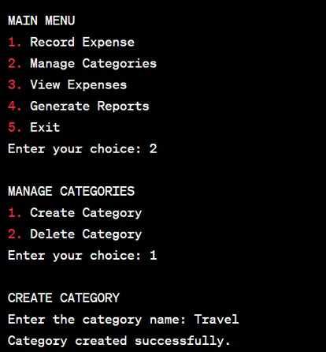 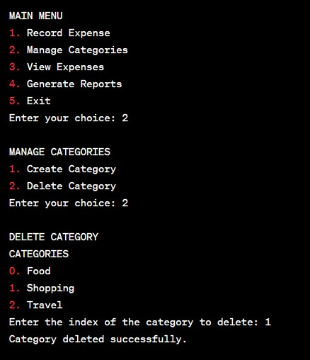

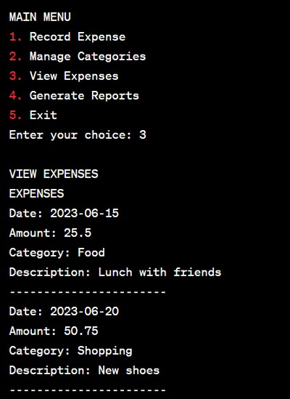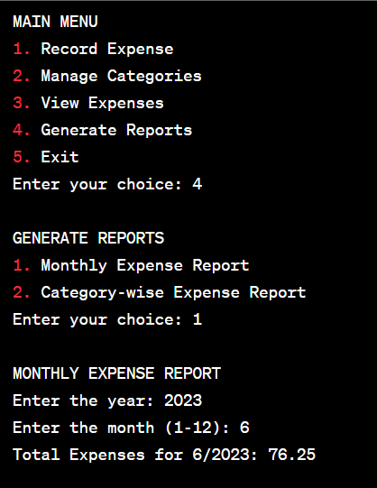

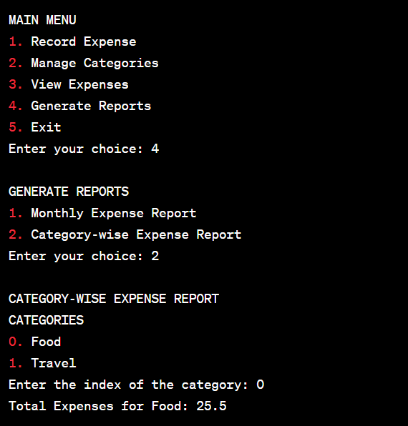

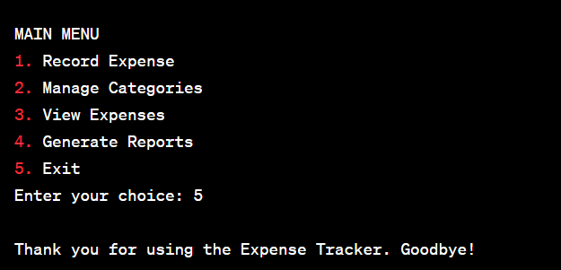

**Conclusion**

In conclusion, the console-based Expense Tracker Application has been successfully developed, providing users with a convenient and efficient tool for managing their personal expenses. The application offers a range of features, including expense recording, category management, report generation, and expense filtering, all designed to assist users in tracking and analyzing their spending habits.

Throughout the development process, the project team encountered challenges and overcame them by implementing robust error handling mechanisms, ensuring data integrity, and providing a user-friendly interface. The application incorporates best practices in software development, including modular design, proper input validation, and data persistence.

The Expense Tracker Application has demonstrated its effectiveness in accurately recording expenses, organizing them by categories, and generating insightful reports. Users can easily track their total expenses, identify spending patterns, and make informed financial decisions based on the generated reports. The application's user-friendly interface and clear instructions make it accessible to users with varying levels of technical expertise.

Furthermore, the project team conducted comprehensive testing to validate the functionality and performance of the application. The results indicated that the application performed reliably and met the specified requirements. The user guide and documentation accompanying the application provide clear instructions for users to navigate and utilize its features effectively.

Overall, the Expense Tracker Application has fulfilled its objectives of providing users with a reliable, easy-to-use tool for managing their personal expenses. It empowers users to gain control over their finances, make informed financial decisions, and track their spending habits with ease.

The success of the Expense Tracker Application opens up possibilities for future enhancements and expansions. The application could be further developed to include features such as data synchronization across devices, integration with external financial systems, and advanced reporting capabilities. Additionally, user feedback and suggestions can be incorporated to enhance the user experience and cater to specific user requirements.

The project team would like to express its gratitude to the Upskill Campus and all those who provided guidance, support, and feedback throughout the development process. The valuable insights and assistance have contributed significantly to

the successful completion of this internship project.

In conclusion, the console-based Expense Tracker Application has proved to be a valuable asset in personal finance management. It empowers users to take control of their expenses, make informed financial decisions, and ultimately achieve their financial goals.

**Future Enhancements**

While the console-based Expense Tracker Application has been successfully developed and meets the current requirements, there are several potential areas for future enhancements and expansions. These enhancements aim to further improve the functionality, usability, and overall user experience of the application. Some potential future enhancements include:

* 1. **Mobile Application**

One potential future enhancement is to develop a mobile application version of the Expense Tracker. A mobile app would provide users with the flexibility to record expenses on the go, making it more convenient and accessible. The mobile app could also leverage features such as location-based expense tracking, receipt scanning, and real-time expense updates.

* 1. **Cloud Sync and Backup**

Implementing cloud synchronization and backup functionality would allow users to store their expense data securely in the cloud. This feature ensures that users can access their expense records from multiple devices and provides data backup to prevent any loss of important financial information. Integration with popular cloud storage platforms could be considered for seamless synchronization and data security.

###### Budgeting and Goal Tracking

Introducing budgeting and goal tracking features would enable users to set spending limits for different expense categories and track their progress towards financial goals. The application could provide visual representations of budget utilization, send alerts when approaching budget limits, and provide insights into savings and expenditure patterns. This would help users stay on track with their financial targets.

###### Advanced Reporting and Analytics

Expanding the reporting capabilities of the Expense Tracker Application can provide users with more in-depth insights into their spending habits. Advanced reporting and analytics features can include data visualizations, trend analysis, expense projections, and comparison charts. These features would enable users to gain a deeper understanding of their financial behavior and make more informed decisions.

###### Integration with Financial Services

Integrating the Expense Tracker Application with external financial services, such as online banking platforms or expense management tools, would enhance its functionality and streamline financial management processes. Integration could allow for automatic expense categorization, transaction syncing, and seamless data transfer between systems, reducing manual effort and improving accuracy.

###### User Interface Enhancements

Continued improvement of the user interface (UI) can enhance the overall user experience of the application. User interface enhancements can include improved design elements, intuitive navigation, and customizable display preferences. A visually appealing and user-friendly UI would make the application more engaging and intuitive for users.

These are just a few potential future enhancements for the Expense Tracker Application. The specific enhancements chosen will depend on user feedback, market demand, and the project team's resources and priorities. Continual evaluation and incorporation of user feedback will ensure that the application remains relevant and valuable to users.

**Acknowledgements**

The successful completion of this internship project would not have been possible without the support, guidance, and contributions of various individuals and organizations. The project team would like to express its sincere gratitude to the following:

**Upskill Campus:** We would like to thank Upskill Campus for providing us with the opportunity to undertake this internship project. Their support, resources, and mentorship have been instrumental in the successful development of the console-based Expense Tracker Application.

**Friends and Family:** We would like to express our appreciation to our friends and family members for their understanding, encouragement, and support throughout the project. Their belief in our abilities and unwavering support have been a source of motivation and inspiration.

**Open-Source Community:** We acknowledge the contributions of the open-source community, whose libraries, frameworks, and code samples have been instrumental in the development of the Expense Tracker Application. Their dedication to sharing knowledge and expertise has greatly facilitated the project's progress.

**Others:** We also acknowledge all those who have directly or indirectly contributed to the project's success but are not mentioned explicitly. Your support and encouragement have been highly appreciated.

The completion of this project has been a collective effort, and we are grateful for the support and contributions of everyone involved. Thank you for being part of this journey and for helping us make this project a reality.

### References

During the development of the console-based Expense Tracker Application, we referred to various sources of information, including research papers, online articles, books, and documentation. The following list provides the references used in the project:

Java Documentation Oracle Available at:https://docs.oracle.com/javase/8/docs/

Stack Overflow. Online community for programming-related questions and answers. Available at: https://stackoverflow.com/

GitHub. Online platform for hosting and collaborating on code repositories. Available at: https://github.com/

UpSkill Campus. Internship program and educational platform. Available at: https://[www.upskillcampus.com/](http://www.upskillcampus.com/)